**WEB TECHNOLOGY**

**Assignment-1**

**[ 1JT18IS049 Rachana A ]**

**Program-1:**

**Write a JavaScript to design a simple calculator to perform the following operations: Sum, Product, Difference and Quotient.**

CODE:

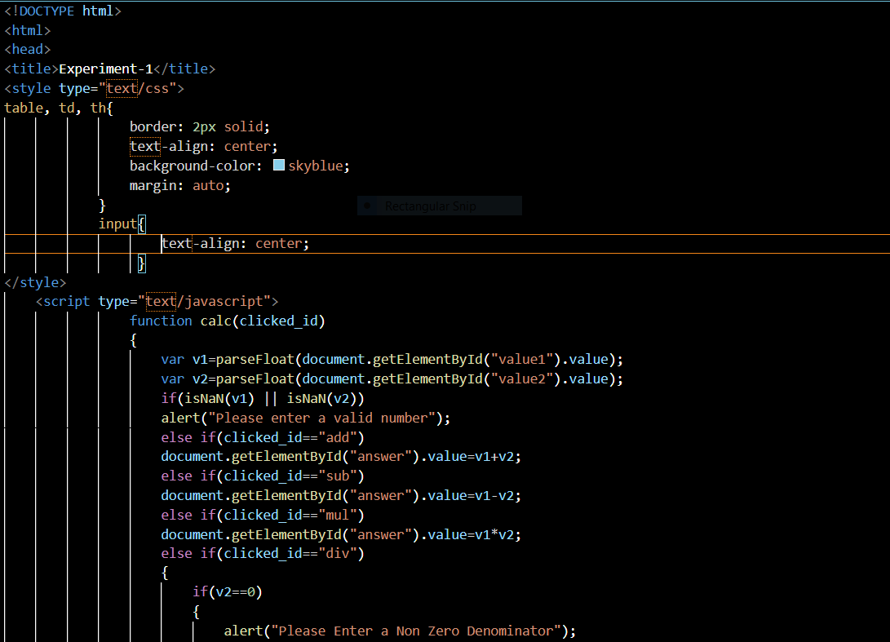

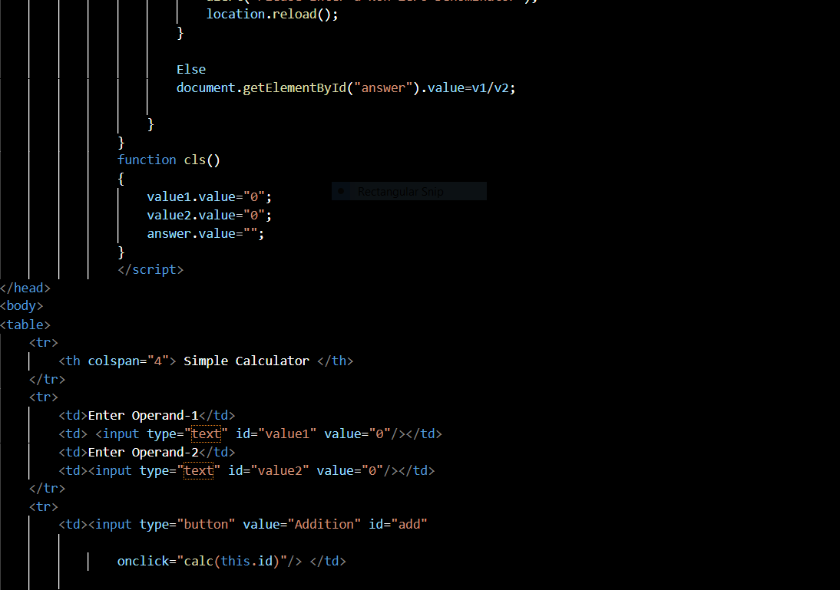

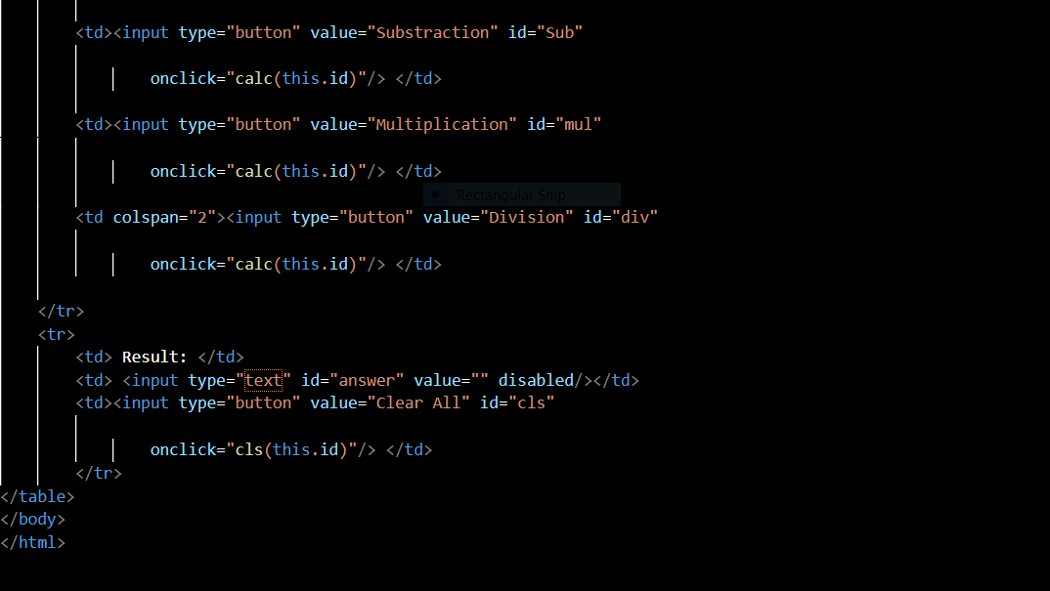

**OUTPUT:**

**Addition:**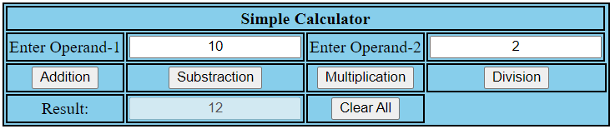

**Subtraction:**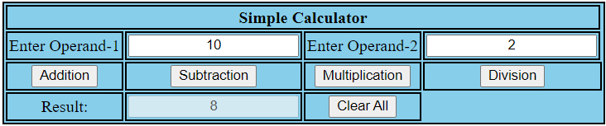

**Multiplication:**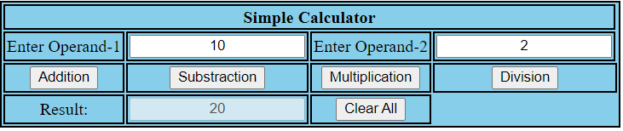

**Division:**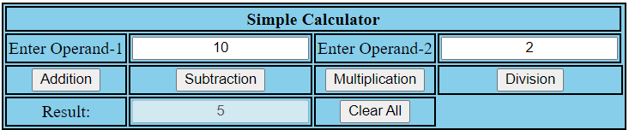

**Test Cases:**

|  |  |  |  |  |
| --- | --- | --- | --- | --- |
| **Test No.** | **Input Parameters** | **Expected O/P** | **Obtained O/P** | **Remarks** |
| **1.** | V1 = 10  V2 = 2 | Addition = 12 | Addition = 12 | **PASS** |
| Subtraction = 8 | Subtraction =8 |
| Product = 20 | Product = 20 |
| Division = 5 | Division = 5 |
| **2.** | V1 = 10.0  V2 = 2.0 | Addition = 12 | Addition = 12 | **PASS** |
| Subtraction =8 | Subtraction =8 |
| Product = 20 | Product = 20 |
| Division = 5 | Division =5 |
| **3.** | V1 = 2  V2 = 10 | Addition = 12 | Addition = 12 | **PASS** |
| Subtraction = -8 | Subtraction = -8 |
| Product = 20 | Product = 20 |
| Division = 0.2 | Division = 0.2 |
| **4.** | V1 = 0  V2 = 10 | Addition = 10 | Addition = 10 | **PASS** |
| Subtraction = -10 | Subtraction = -10 |
| Product = 0 | Product = 0 |
| Division = 0 | Division = 0 |
| **5.** | V1 = 10  V2 = 0 | Addition = 10 | Addition = 10 | **PASS** |
| Subtraction = 10 | Subtraction = 10 |
| Product = 0 | Product = 0 |
| Division = Infinity | Division = Infinity |
| **6.** | V1 = xyz  V2 = 10 | Enter valid number | Enter valid number | **PASS** |

**code:** [**https://github.com/rachanajitwta/1JT18IS049_WT**](https://github.com/rachanajitwta/1JT18IS049_WT)

**Challenge Assignment – 1**

**CODE:**

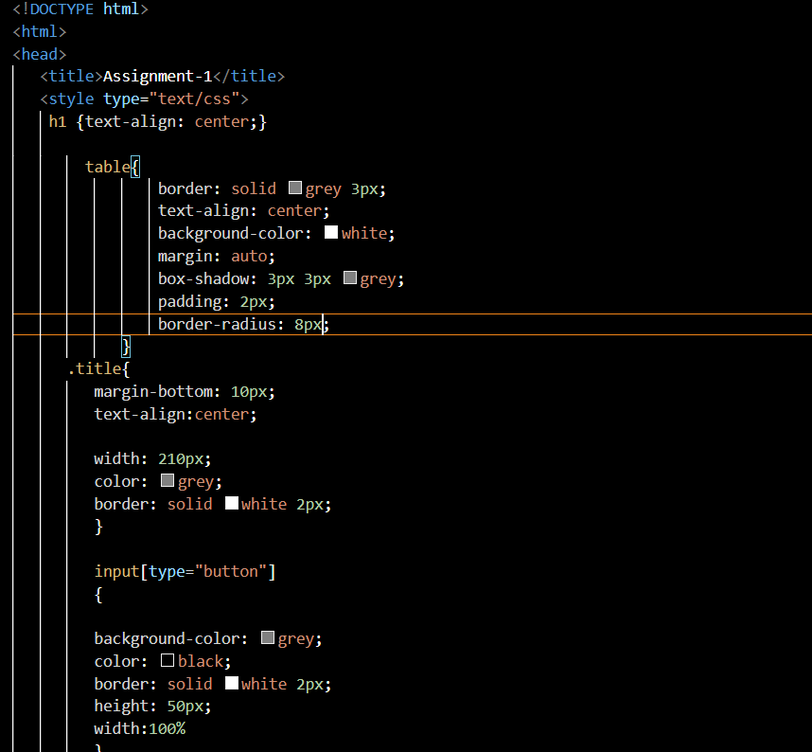

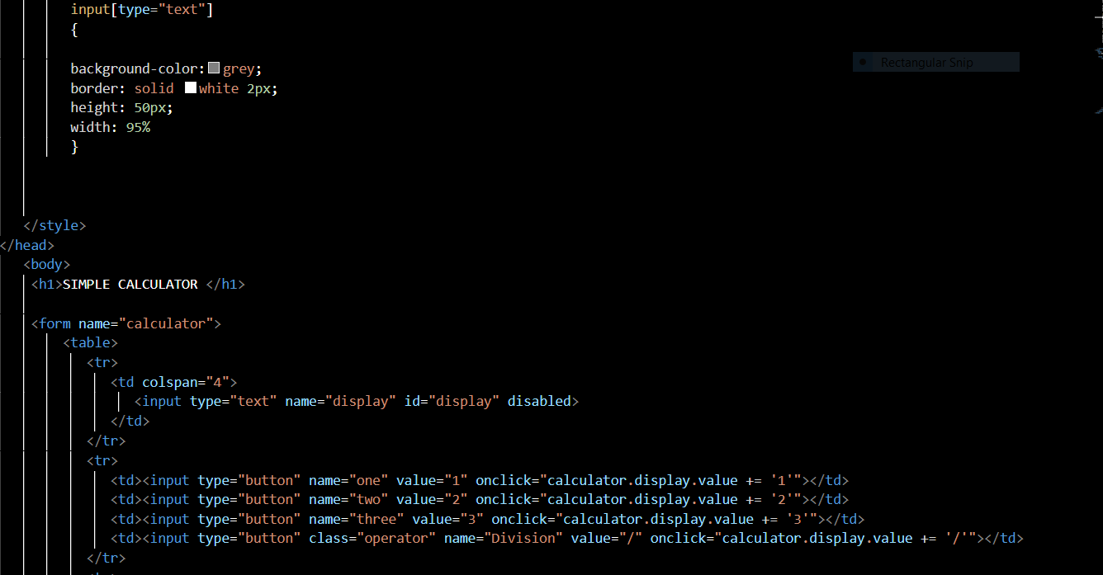

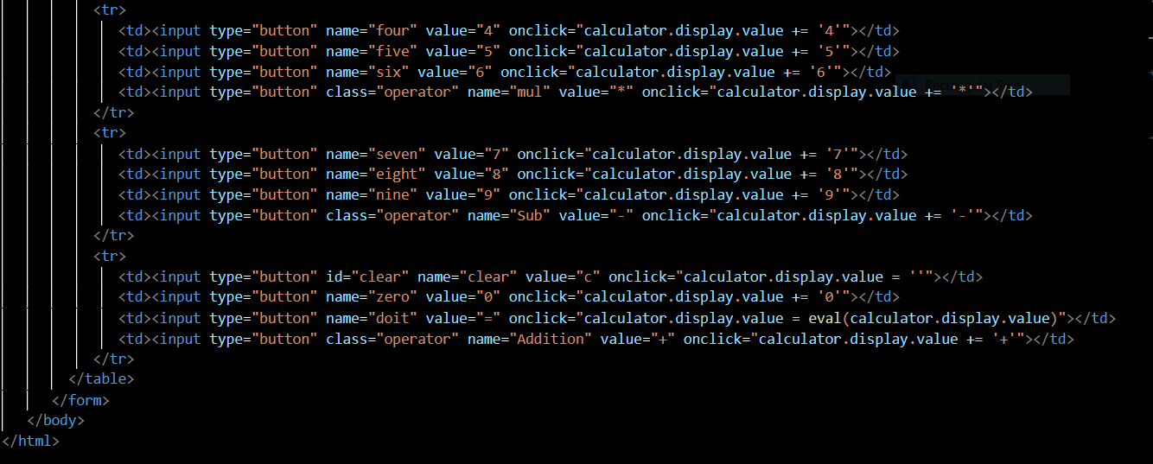

**Screenshots:**

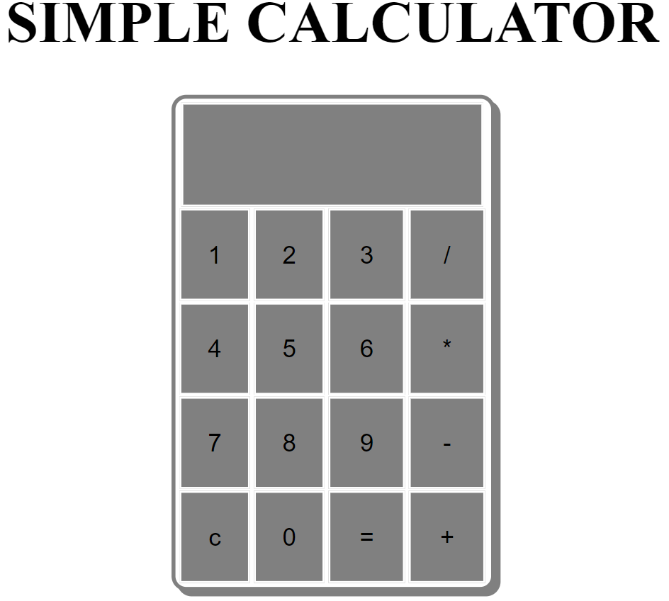

**Output:**

**Addition:**

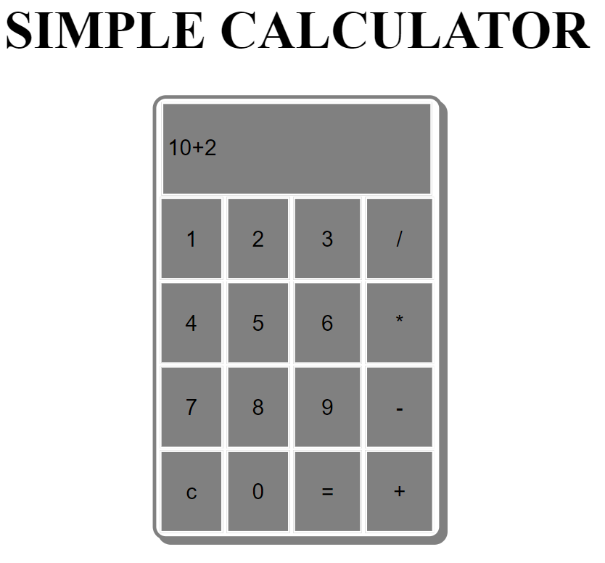 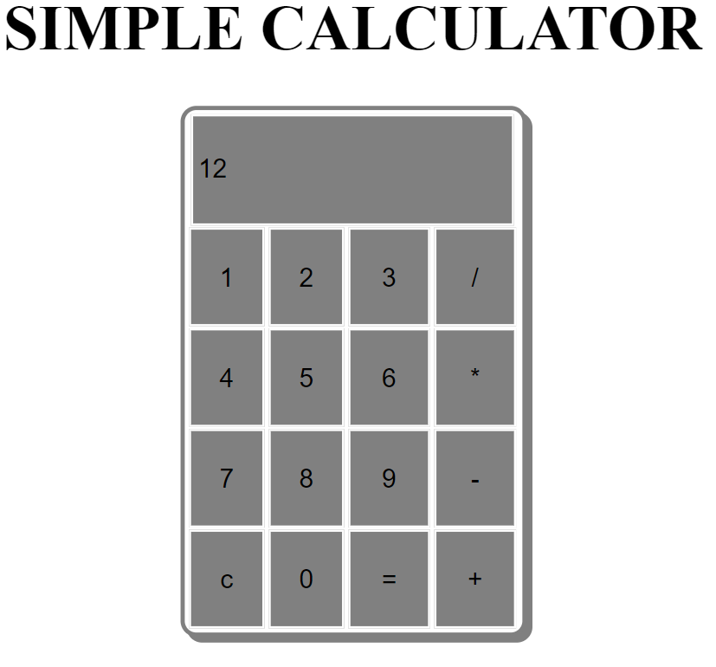

**Output:**

**Subtraction:**

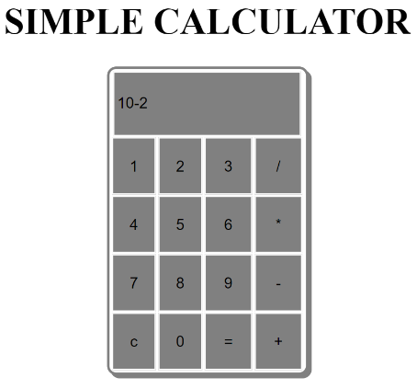 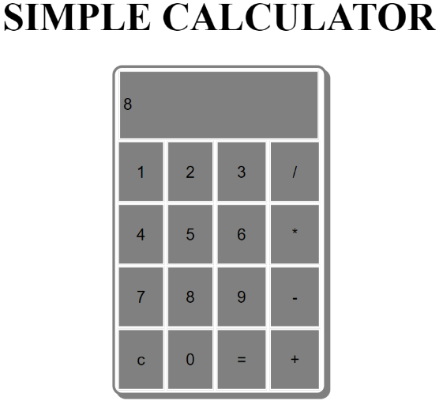

**Output:**

**Multiplication:**

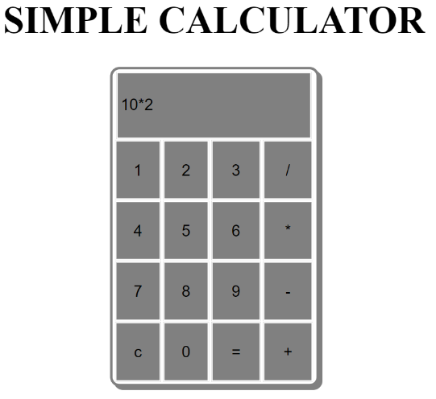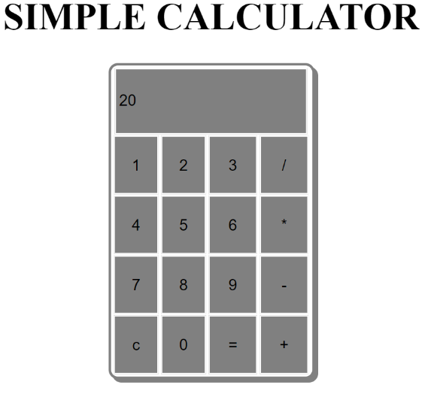

**Division:**

**Output:**

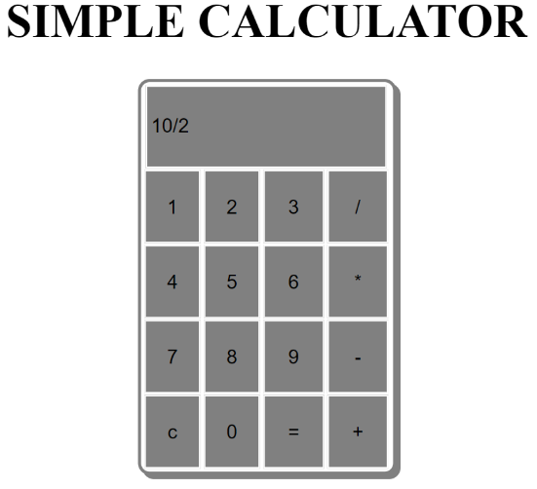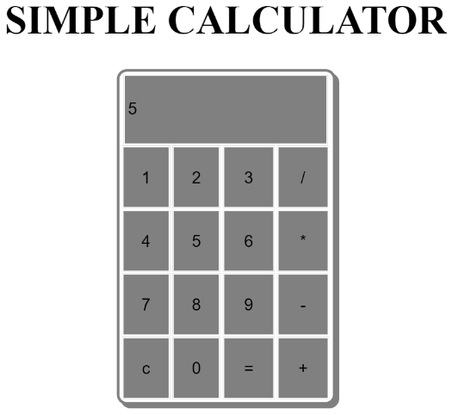

**Test Cases:**

|  |  |  |  |  |
| --- | --- | --- | --- | --- |
| **Test No.** | **Input Parameters** | **Expected O/P** | **Obtained O/P** | **Remarks** |
| **1.** | V1 = 10  V2 = 2 | Addition = 12 | Addition = 12 | **PASS** |
| Subtraction = 8 | Subtraction = 8 |
| Product = 20 | Product = 20 |
| Division = 5 | Division = 5 |
| **2.** | V1 = 10.0  V2 = 2.0 | Addition = 12 | Addition = 12 | **PASS** |
| Subtraction = 8 | Subtraction = 8 |
| Product = 20 | Product = 20 |
| Division = 5 | Division = 5 |
| **3.** | V1 = 2  V2 = 10 | Addition = 12 | Addition = 12 | **PASS** |
| Subtraction = -8 | Subtraction = -8 |
| Product = 20 | Product = 20 |
| Division = 0.2 | Division = 0.2 |
| **4.** | V1 = 0  V2 = 10 | Addition = 10 | Addition = 10 | **PASS** |
| Subtraction = -10 | Subtraction = -10 |
| Product = 0 | Product = 0 |
| Division = 0 | Division = 0 |
| **5.** | V1 = 10  V2 = 0 | Addition = 10 | Addition = 10 | **PASS** |
| Subtraction = 10 | Subtraction = 10 |
| Product = 0 | Product = 0 |
| Division = Infinity | Division = Infinity |
| **6.** | V1 = xyz  V2 = 5 | Enter valid number | Enter valid number | **PASS** |

**code:** [**https://github.com/rachanajitwta/1JT18IS049_WT**](https://github.com/rachanajitwta/1JT18IS049_WT)

**[1JT18IS049 Rachana A]**